KRITIS-Dachgesetz Compliance for Log360
Tagline: Strengthen German critical infrastructure resilience and meet KRITIS-Dachgesetz obligations with Log360.

Overview
The KRITIS-Dachgesetz (Critical Infrastructure Umbrella Law / CER) Compliance extension for Log360 supports German critical infrastructure operators in meeting the cross-sector security monitoring, incident reporting, and resilience requirements under the German implementation of the EU CER Directive.
Log360 collects and correlates logs from OT systems, IT environments, cloud platforms, and network infrastructure, providing security teams with continuous visibility into threats targeting critical facilities. Compliance teams can assess control coverage, detect incidents, and generate documentation for BBK and sectoral authority oversight.

Key Features
- Generate audit reports aligned to KRITIS-Dachgesetz requirements covering physical and cyber security monitoring, incident detection, and access control for critical facilities.
- Monitor operational technology and IT systems for unauthorized access, anomalous commands, and configuration changes affecting critical infrastructure operations.
- Leverage threat intelligence and correlation rules to detect advanced attacks targeting KRITIS sectors including energy, water, transport, and health.
- Export compliance evidence in PDF and CSV formats for BBK notifications, sectoral authority reporting, and internal critical infrastructure governance.
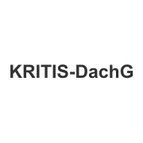
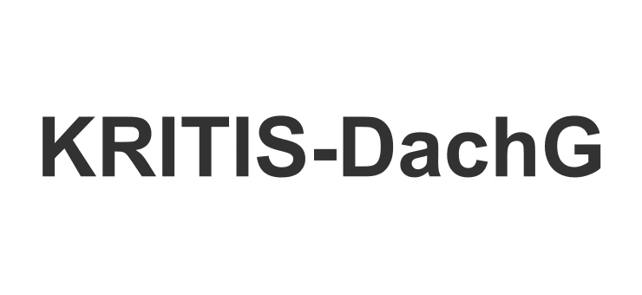

Screenshots
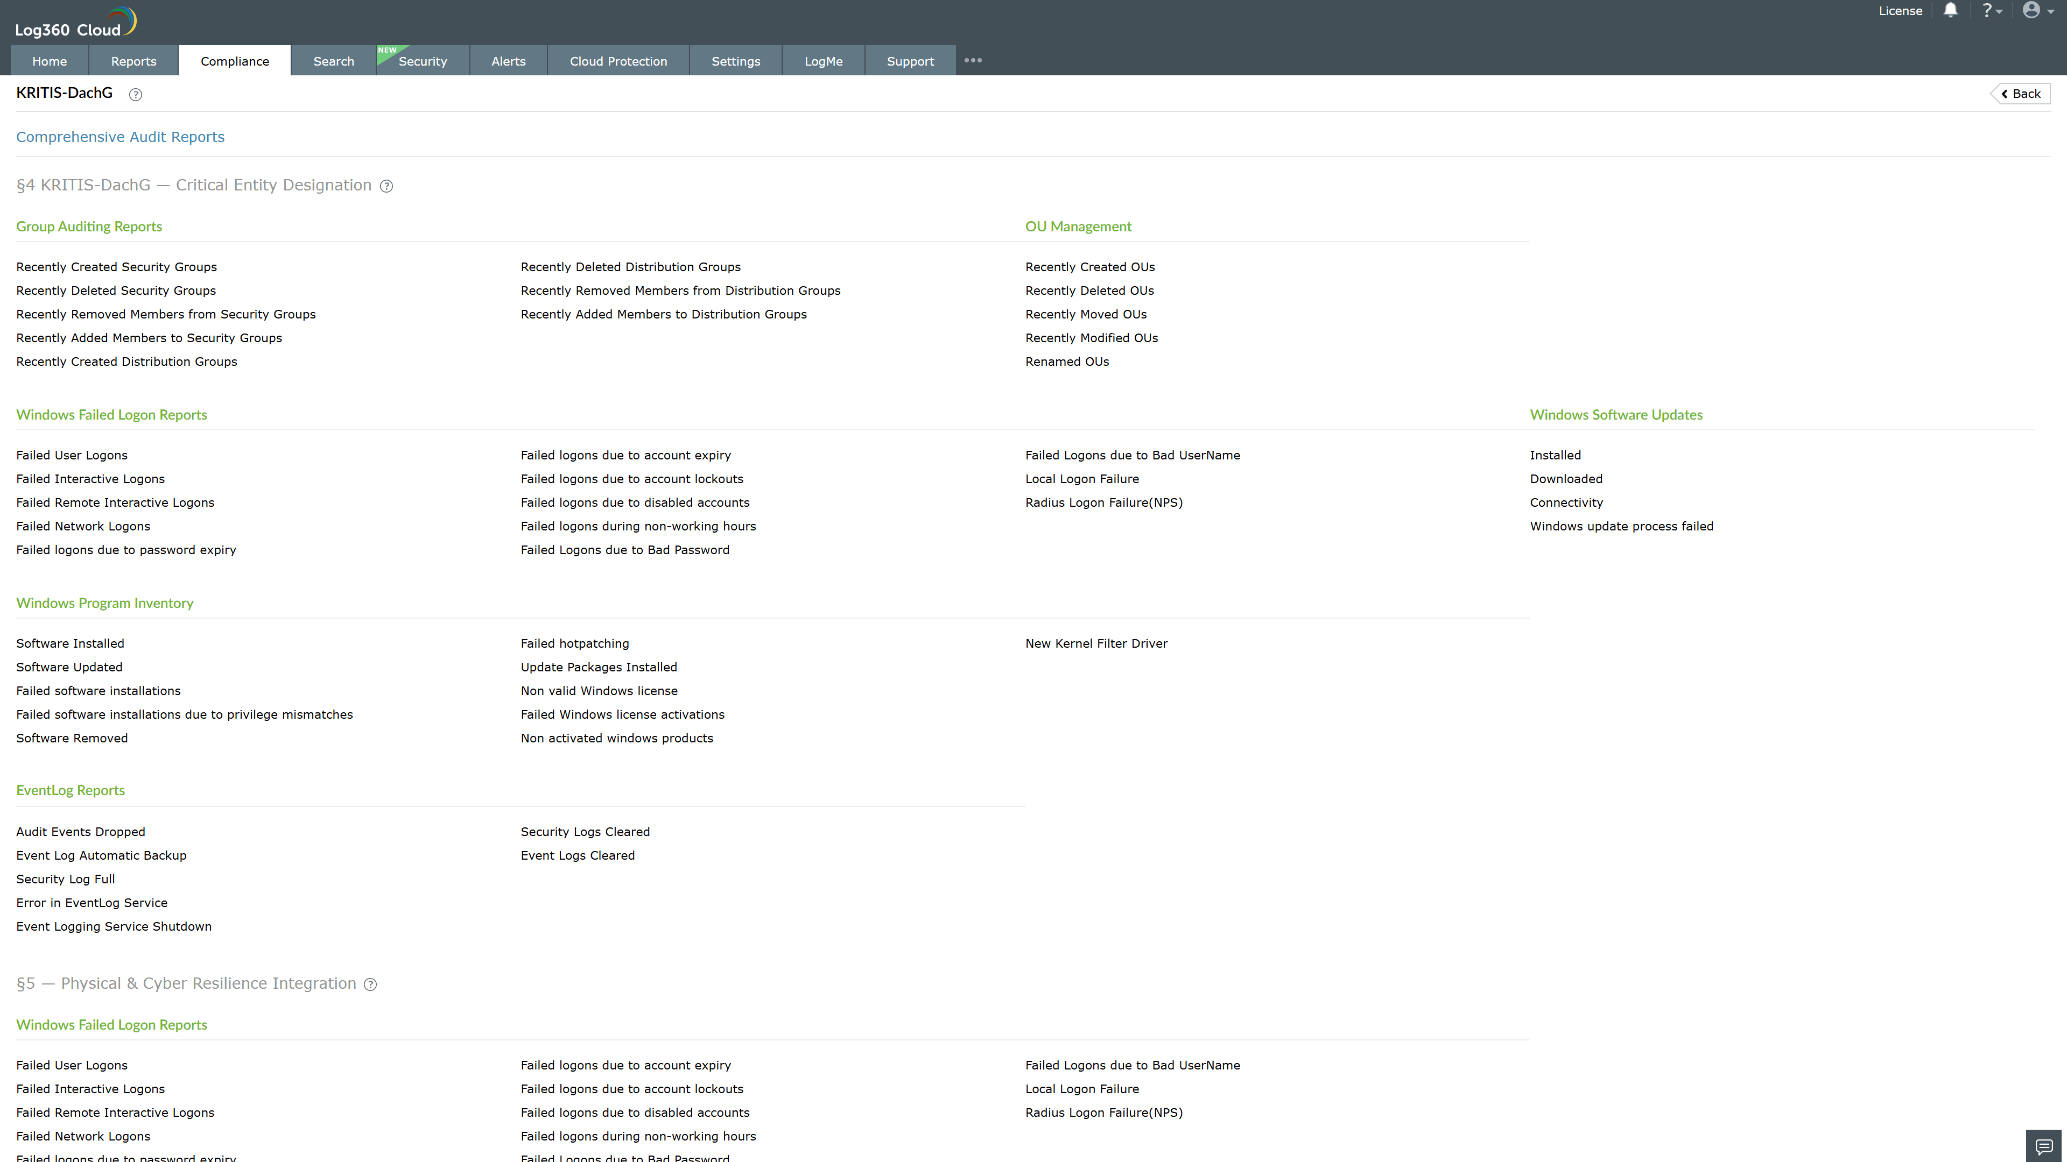
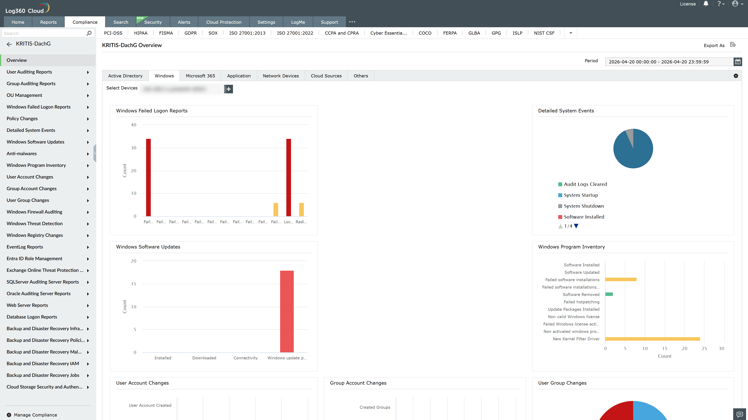
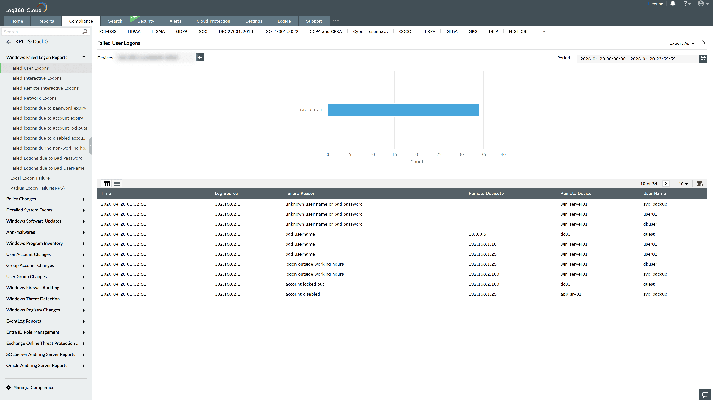
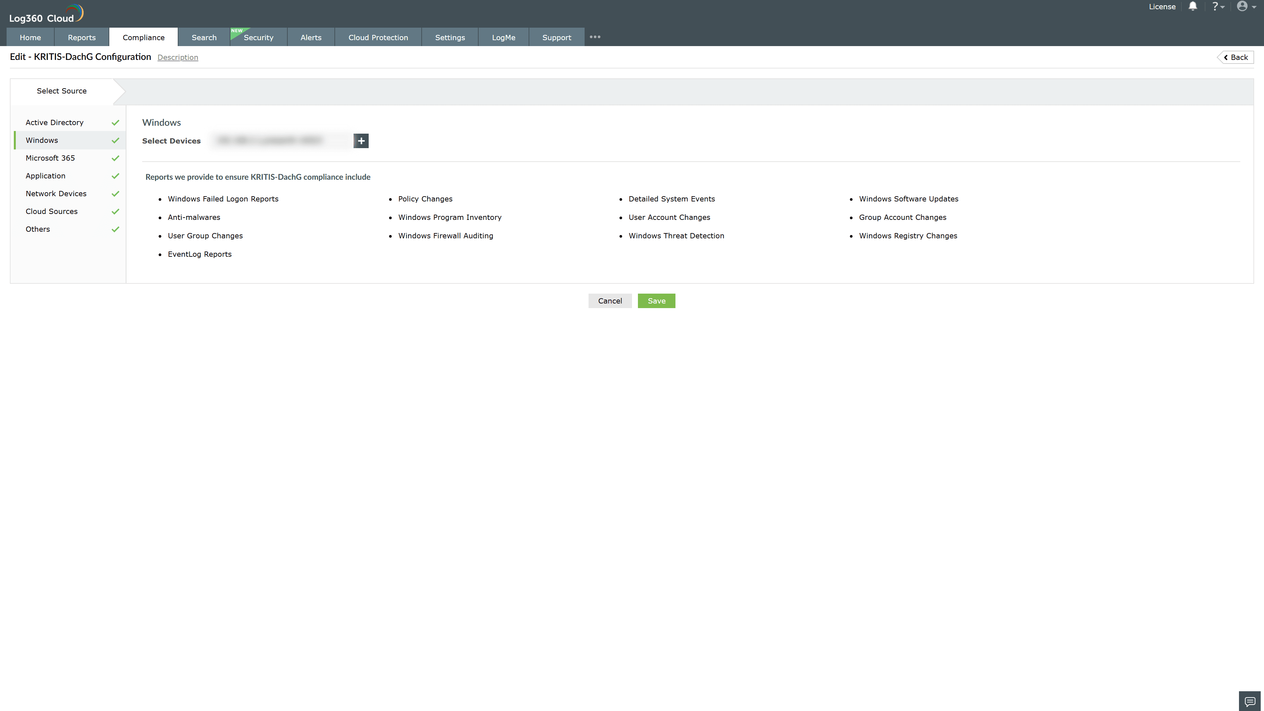

Valid Submission : Yes
Supported Editions : Free, Basic, Standard, Professional, MSSP
Help Document : https://www.manageengine.com/log-management/help/integrations/compliance-extensions.html
Help Video : Not provided
Tags : Log360, Compliance, Privacy monitoring, Data privacy, Regulatory compliance
Supported DCs : US, IN, JP, CA, AU, UK and EU
Privacy Policy:
Terms of Service:
Release Notes:
Predefined reports for the kritis dachgesetz compliance

